Allo-HSCT compared with immunosuppressive therapy for acquired aplastic anemia: Is superiority a one-sided understanding?
Yangmin Zhu¹, Qingyan Gao¹, Jing Hu¹, Xu Liu¹, Dongrui Guan¹, Fengkui Zhang¹
¹Department of Therapeutic Center of Anemia, Institute of Hematology and Blood Diseases Hospital, Chinese Academy of Medical Science & Peking Union Medical College (CAMS & PUMC), Tianjin, China

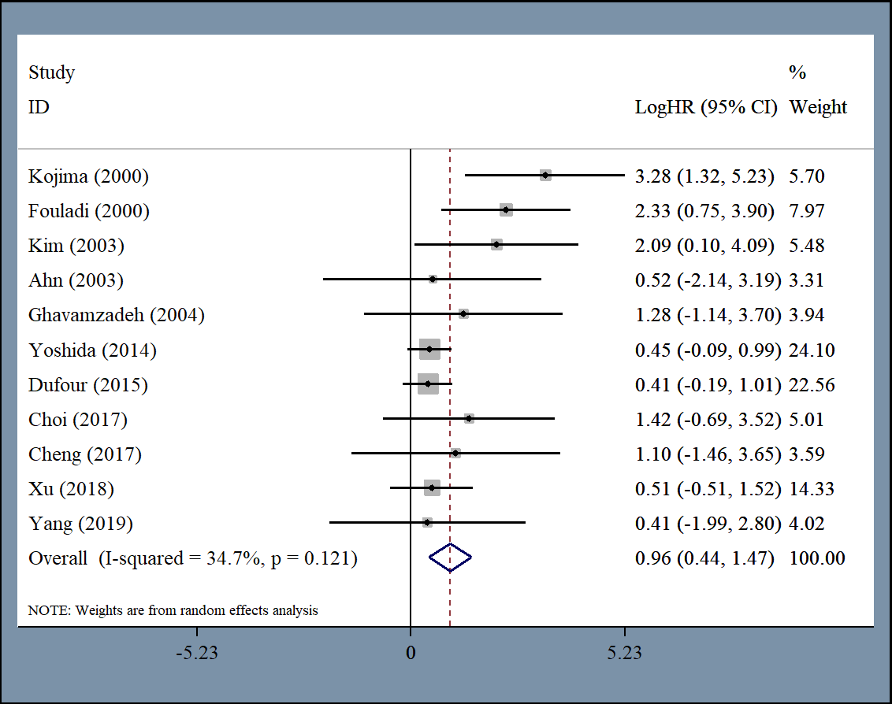
Figure S1. Significantly longer OS among patients undergoing first-line allo-HSCT compared to first-line IST after excluding four studies with high heterogeneity.

